FitCV  UI DESIGN  Two design options for the main screen and UC-02 workflow  AI-powered CV screening and job readiness platform | PROJECT ASSIGNMENT 3  COURSE  Introduction to Software Engineering  PROJECT  FitCV  PRIMARY ACTOR  Student / Job Seeker  MAIN USE CASE  UC-02 - Analyze CV against Job Description  VERSION  1.0  DATE  25 July 2026

DOCUMENT CONTROL
Scope and submission compliance
This document consolidates all UI design outputs required by PA3. It uses the current FitCV implementation as Option A and provides a structurally different Option B for each selected screen.
Revision history
Date | Version | Description | Author
25/07/2026 | 1.0 | Initial PA3 UI Design submission with six high-fidelity design outputs. | FitCV Project Team

PA3 UI requirement checklist
PA3 requirement | Status | Evidence in this document
Main screen and 1-2 screens for the main use case | Complete | Student Dashboard, Analyzer Input, Analyzer Result
Two UI designs or options for each screen | Complete | Option A and Option B for all three screens
Purpose, content and usage description | Complete | Compact specification on every Option A screen page
All design outputs in one document named UI Design | Complete | This document
UI matches modeled use cases | Complete | UC-02 traceability and alternative-flow states
Sufficient labels and controls | Complete | Upload/select CV, add JD, validate, analyze, review evidence and suggestions

DESIGN BASIS
Use-case alignment and visual language
Selected main use case
UC-02 - Analyze CV against Job Description. The Student selects or uploads a CV, provides a complete JD, runs evidence-based matching, and reviews the saved result.

MAIN USER FLOW  1. Open Dashboard and start New Analysis.  2. Select or upload a PDF/DOCX CV.  3. Paste, upload or select a job description.  4. Review readiness and validation feedback.  5. Run analysis and wait for grounded processing.  6. Review score, label, category evidence and gaps.  7. Continue to prioritized improvement suggestions. | DESIGN SYSTEM  Student accent #2563EB Application canvas #F8FAFC  Primary text #0F172A Success #16A34A  Warning #D97706 Border #E2E8F0  Typography: Aptos / Inter style. 8 px spacing rhythm. Lucide line icons. Scores always include a number and text label, never color alone.

SCREEN 1 - OPTION A
Student Dashboard
Option A is the implemented React/Vite interface captured from the current FitCV source.
PURPOSE  Give the Student a concise readiness overview and a clear entry point to UC-02. | WHAT IT SHOWS  Average score, analyzed CVs, tracked applications, recent activity and quick actions. | HOW USERS USE IT  Select New Analysis, Continue Last Analysis or Match Analyzer to start or resume UC-02.

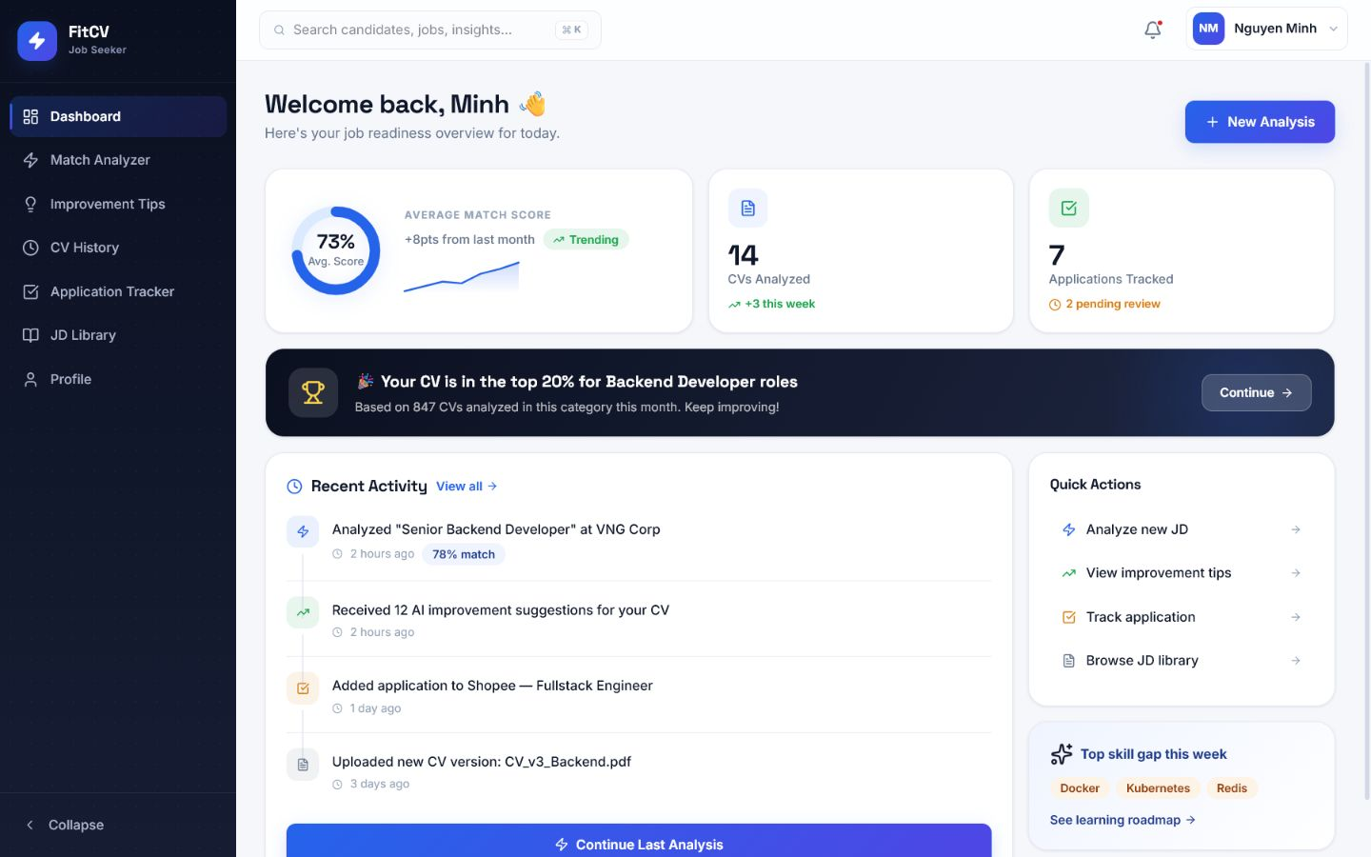
Figure 1A. Option A - Implemented analytics-first bento dashboard.

SCREEN 1 - OPTION B
Student Dashboard - Alternative
DESIGN DIRECTION  Task-first command center with a prominent target-job question. | KEY IMPROVEMENT  Reduces scanning before the primary action and previews selected CV/JD sources directly on the dashboard. | RECOMMENDATION  Preferred for the next iteration because it exposes the UC-02 starting action more clearly.

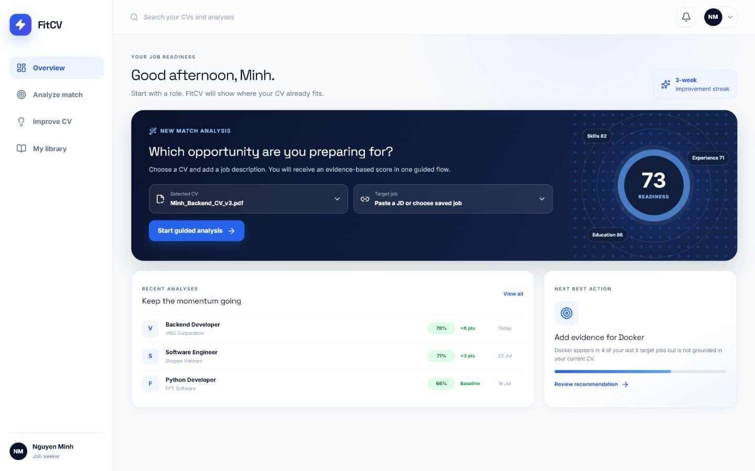
Figure 1B. Option B - Alternative task-first dashboard.

SCREEN 2 - OPTION A
CV and JD Match Analyzer - Input
Option A is the implemented React/Vite interface captured from the current FitCV source.
PURPOSE  Collect both source documents required by UC-02 and prevent incomplete analysis. | WHAT IT SHOWS  CV drag-and-drop, PDF/DOCX and 10 MB rules, JD text area, upload action and Analyze Match button. | HOW USERS USE IT  Upload/select a CV, paste or upload the JD, correct any validation message, then select Analyze Match.

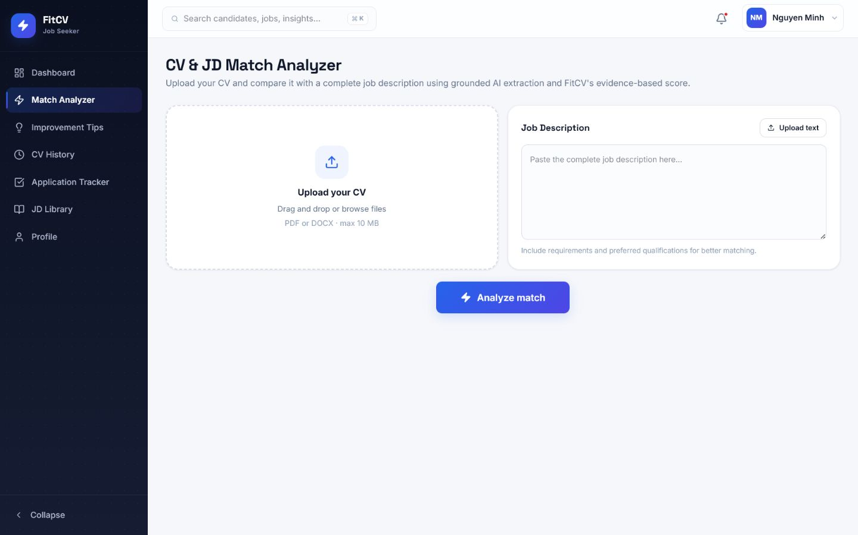
Figure 2A. Option A - Implemented simultaneous two-column analyzer input.

SCREEN 2 - OPTION B
CV and JD Match Analyzer - Input - Alternative
DESIGN DIRECTION  Guided three-step source preparation workflow. | KEY IMPROVEMENT  Makes CV parse readiness, JD completeness, privacy handling and final review explicit before analysis. | RECOMMENDATION  Preferred for novice users and for closer mapping to UC-02 steps 2-7 and its alternative flows.

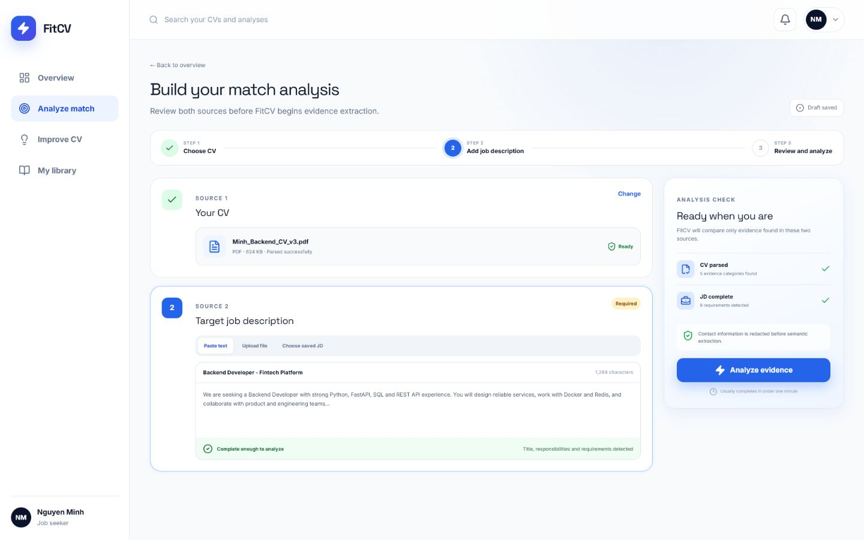
Figure 2B. Option B - Alternative guided stepper with readiness summary.

SCREEN 3 - OPTION A
CV and JD Match Analyzer - Result
Option A is the implemented React/Vite interface captured from the current FitCV source.
PURPOSE  Display the completed UC-02 result in a clear score-first summary. | WHAT IT SHOWS  Overall score and label, category breakdown, screening alignment, matched/missing skills and next steps. | HOW USERS USE IT  Review the score and evidence, then select View Improvement Suggestions to continue to UC-03.

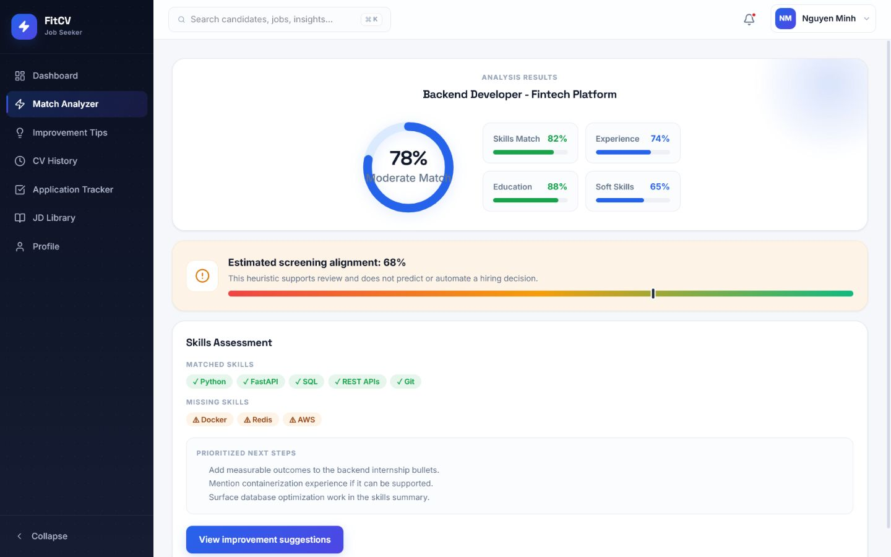
Figure 3A. Option A - Implemented score-first result summary.

SCREEN 3 - OPTION B
CV and JD Match Analyzer - Result - Alternative
DESIGN DIRECTION  Source-grounded evidence comparison workspace. | KEY IMPROVEMENT  Places CV quotes beside JD requirements and separates matched, partial and missing evidence from recommended actions. | RECOMMENDATION  Preferred for explainability, review quality and the FitCV rule that a score must not automate hiring decisions.

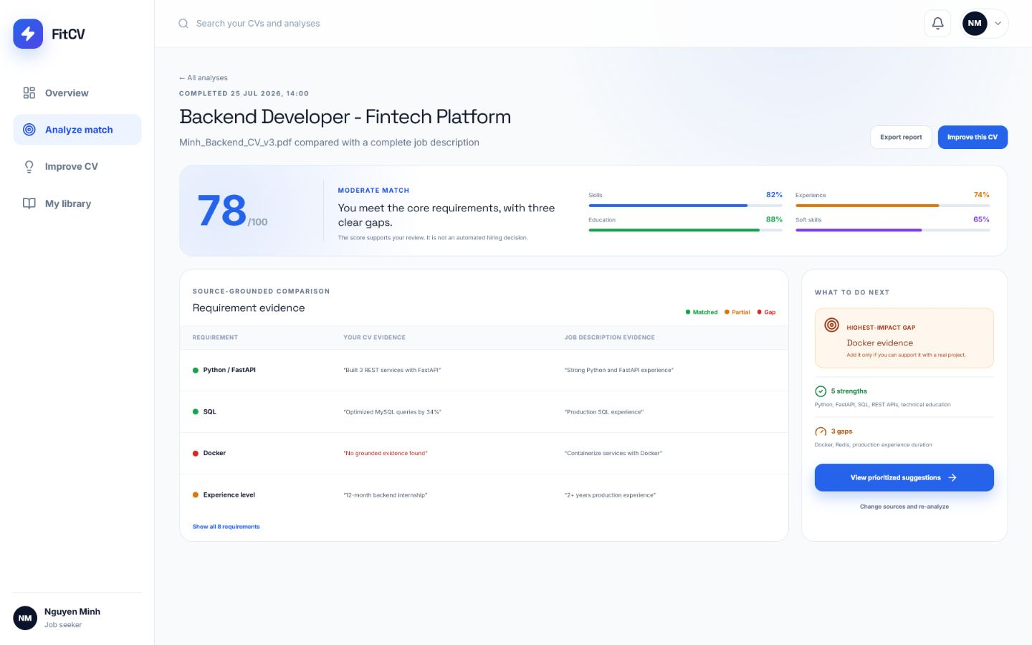
Figure 3B. Option B - Alternative evidence-first result workspace.

TRACEABILITY
UC-02 to UI control mapping
The mapping below demonstrates that both design directions contain sufficient labels, controls and feedback for the documented basic and alternative flows.
UC-02 step | Required behavior | UI control or feedback | Screen
1 | Open the Match Analyzer page. | New Analysis CTA and Match Analyzer navigation. | Dashboard
2 | Select or upload a CV. | File drop zone, CV selector, file name, size and parse status. | Analyzer Input
3 | Enter, upload or select a JD. | Paste Text, Upload File and Choose Saved JD actions. | Analyzer Input
4 | Validate both sources. | Accepted format/size guidance, Required label and readiness summary. | Analyzer Input
5 | Retrieve parsed CV content. | Parsed Successfully or Processing status; analysis is disabled while unavailable. | Analyzer Input
6 | Extract JD requirements. | JD completeness feedback and detected requirement summary. | Analyzer Input
7 | Run AI-assisted matching. | Analyze button, processing status and retry-safe error state. | Analyzer Input
8 | Save and display result. | Score, label, breakdown, evidence, gaps and suggestions action. | Analyzer Result
Alternative-flow UI states
JD empty or too short  Inline error names the minimum requirement and returns focus to JD input. | CV parsing in progress  Processing status is visible and Analyze remains disabled until parsing succeeds. | AI timeout or quota error  Retry message is shown; the UI never displays a fabricated completed result. | Invalid AI output  Analysis is marked Failed with a safe retry action and no score is presented.

DESIGN DECISION
Comparison and recommended direction
Screen | Option A strength | Option B strength | Recommended
Student Dashboard | Dense readiness overview and strong continuity with the existing product. | Makes the primary UC-02 action immediately visible. | Option B
Analyzer Input | Fast side-by-side entry for experienced users. | Guided preparation, explicit validation and reduced uncertainty. | Option B
Analyzer Result | Compact score-first review and direct suggestions action. | Best evidence traceability and strongest decision-support framing. | Option B

Final recommendation
Keep Option A as the implementation baseline for the current prototype. Use Option B as the preferred next design iteration because its task-first dashboard, guided source preparation and side-by-side evidence review map more explicitly to UC-02.

Quality and accessibility notes
✓ Overall scores always include both a number and Strong/Moderate/Weak Match text. | ✓ Matched, partial and missing states use text and icons in addition to color. | ✓ Upload controls state PDF/DOCX and 10 MB constraints before selection.
✓ AI output is described as decision support, never as an automatic acceptance or rejection. | ✓ Buttons use direct action labels such as Analyze Match, Improve This CV and Retry. | ✓ The screen hierarchy preserves one primary CTA while keeping secondary actions available.

